
Department of Computer Engineering

Roll No.: B-864
Date:
Experiment No. 1
Aim: Explore the descriptive and inferential analysis from the given dataset.
Theory:
Data analysis is the process of inspecting, cleaning, transforming, and modeling data to discover useful information and support decision-making. One of the most fundamental steps in data analysis is descriptive statistics, which provides a summary of the main characteristics of a dataset.
Descriptive statistics help in understanding the central tendency, dispersion, and distribution of numerical data. In this experiment, a real-world dataset containing specifications and prices of BMW cars is analyzed using Python libraries such as Pandas, NumPy, Matplotlib, and SciPy.

1. Descriptive Analysis
Descriptive analysis focuses on summarizing and describing the main features of a dataset. It helps convert raw data into meaningful information using numerical measures and visual representations. Descriptive statistics do not make predictions; instead, they describe what the data shows.
2. Inferential Analysis
Inferential analysis involves drawing conclusions or making predictions about a population based on a sample of data. It uses probability theory and statistical methods to generalize results beyond the observed dataset.

Measures of Central Tendency
These measures indicate the central or typical value of a dataset.
- Mean:
The arithmetic average of all observations.
It provides an overall summary of the data but is sensitive to extreme values.
- Median:
The middle value of the dataset when arranged in ascending order.
It is resistant to outliers and skewed data.
- Mode:
The value that appears most frequently in the dataset.
Useful for identifying commonly occurring values.
Measures of Dispersion
These measures describe the spread or variability of data values.
- Range:
The difference between the maximum and minimum values.
It gives a basic idea of data variability.
- Standard Deviation:
Measures the average deviation of values from the mean.
A higher standard deviation indicates greater variability in the dataset.

Dataset Description
The dataset consists of various attributes related to BMW vehicles, including:
- Model
- Year
- Price
- Transmission type
- Mileage
- Fuel type
- Road tax
- Mileage per gallon (mpg)
- Engine size
Numerical attributes are extracted from the dataset for statistical analysis.

Dataset:
model | year | price | transmission | mileage | fuelType | tax | mpg | engineSize
5 Series | 2014 | 11200 | Automatic | 67068 | Diesel | 125 | 57.6 | 2
6 Series | 2018 | 27000 | Automatic | 14827 | Petrol | 145 | 42.8 | 2
5 Series | 2016 | 16000 | Automatic | 62794 | Diesel | 160 | 51.4 | 3
1 Series | 2017 | 12750 | Automatic | 26676 | Diesel | 145 | 72.4 | 1.5
7 Series | 2014 | 14500 | Automatic | 39554 | Diesel | 160 | 50.4 | 3
5 Series | 2016 | 14900 | Automatic | 35309 | Diesel | 125 | 60.1 | 2
5 Series | 2017 | 16000 | Automatic | 38538 | Diesel | 125 | 60.1 | 2
2 Series | 2018 | 16250 | Manual | 10401 | Petrol | 145 | 52.3 | 1.5
4 Series | 2017 | 14250 | Manual | 42668 | Diesel | 30 | 62.8 | 2

Code:
import pandas as pd
import numpy as np
import matplotlib.pyplot as plt
from scipy import stats

# Load Dataset
df = pd.read_csv("bmw.csv")

print("First 5 rows of dataset:")
print(df.head())
print("\nDataset Info:")
print(df.info())

num_df = df.select_dtypes(include="number")

# Mean
mean_values = num_df.mean()

# Median
median_values = num_df.median()

# Mode
mode_values = num_df.mode().iloc[0]

# Range
range_values = num_df.max() - num_df.min()

# Standard Deviation
std_dev_values = num_df.std()

# Combine all statistics
statistics_summary = pd.DataFrame(
{
"Mean": mean_values,
"Median": median_values,
"Mode": mode_values,
"Range": range_values,
"Standard Deviation": std_dev_values,
}
)

print("\nDescriptive Statistics Summary:")
print(statistics_summary)

print("\n95% Confidence Intervals for Mean:")
for column in num_df.columns:
data = num_df[column].dropna()
mean = data.mean()
sem = stats.sem(data)
confidence_interval = stats.t.interval(
confidence=0.95, df=len(data) - 1, loc=mean, scale=sem
)
print(f"{column}: {confidence_interval}")

# Visualizations
# Histogram (Distribution)
num_df.hist(figsize=(12, 8))
plt.suptitle("Histogram of Numerical Variables", fontsize=14)
plt.tight_layout()
plt.show()

# Box Plot (Spread & Outliers)
plt.figure(figsize=(10, 6))
num_df.boxplot()
plt.title("Boxplot of Numerical Variables")
plt.xticks(rotation=45)
plt.tight_layout()
plt.show()

# Mean Comparison Bar Chart
plt.figure(figsize=(10, 5))
mean_values.plot(kind="bar")
plt.title("Mean Values of Numerical Variables")
plt.ylabel("Mean")
plt.xticks(rotation=45)
plt.tight_layout()
plt.show()

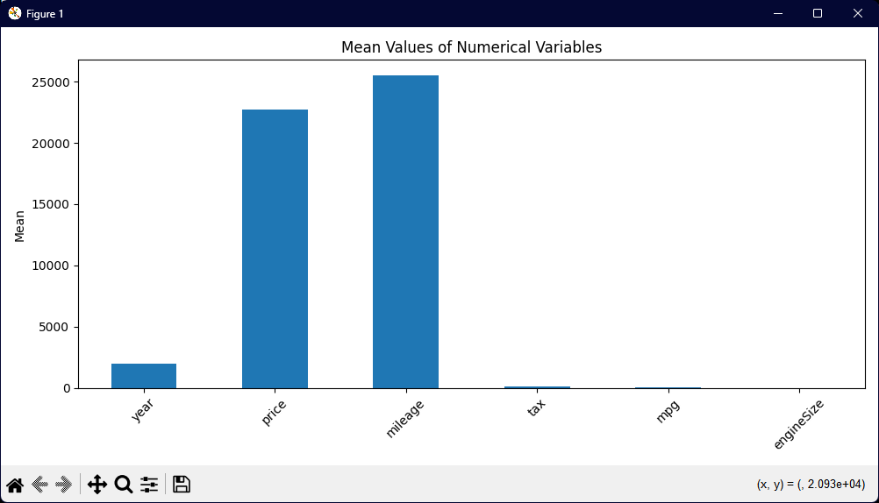
Output:

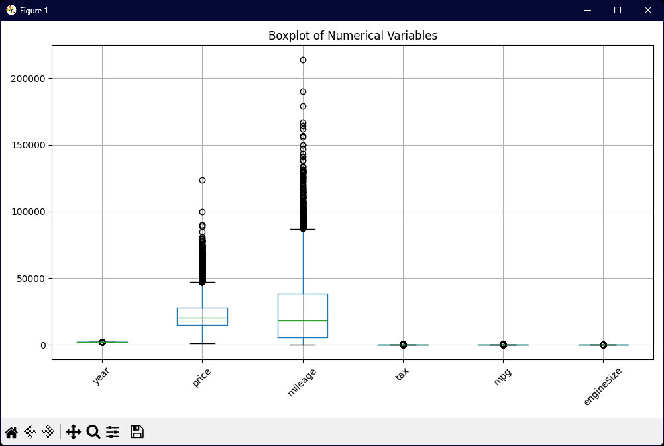

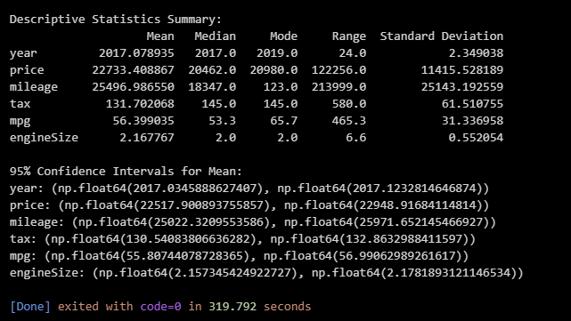

Conclusion
Descriptive analysis summarized the dataset using statistical measures and visualizations, while inferential analysis helped estimate population parameters using sample data. Together, these methods provided meaningful insights and formed a strong foundation for further data analysis.
In this experiment demonstrated the importance of combining descriptive and inferential analysis for effective data interpretation.

